1. **What is Spring Boot?**

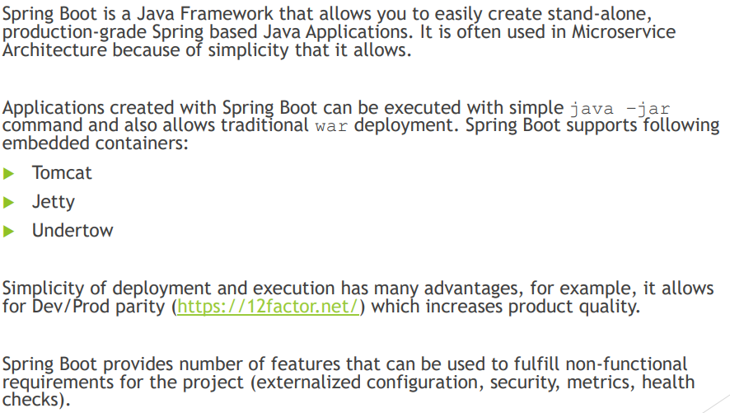

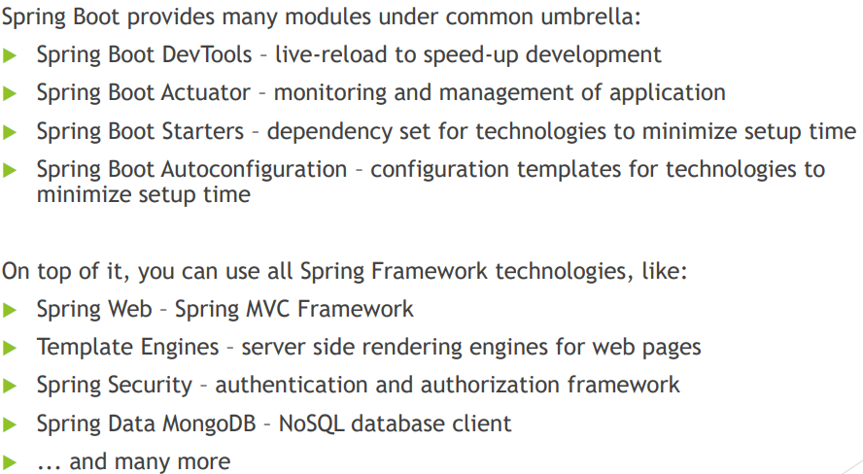

1. **What things affect what Spring Boot sets up? And how to use @Conditional?**

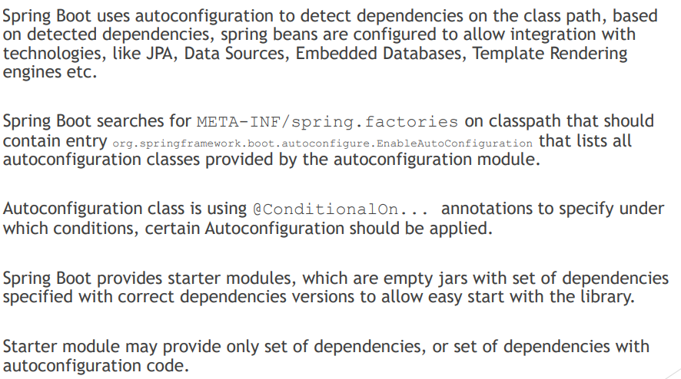

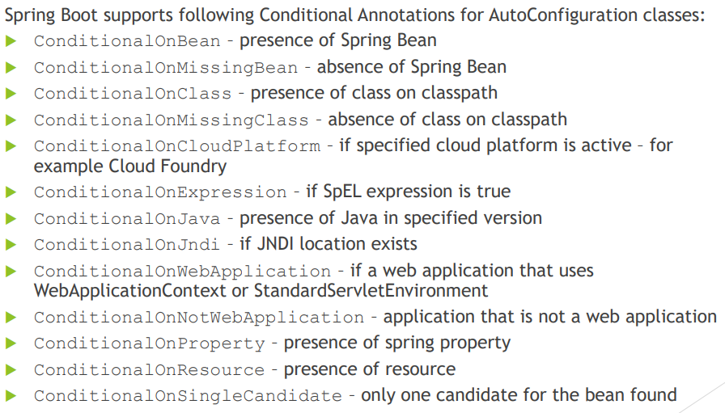

If we want to override AutoConfiguration then we need to follow these steps:

1. Exclude the autoconfig from the project:

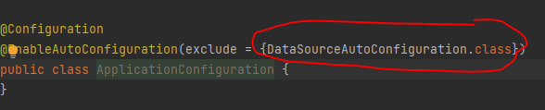

1. We add our custom dependency in pom.xml:

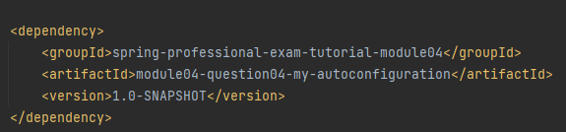

1. Then in my-autoconfig project we define the spring.factories inside /META-INF:

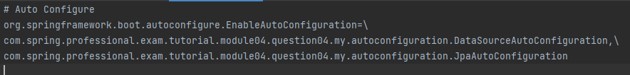

1. Then we create our config:

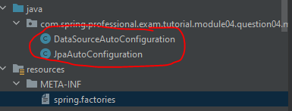

1. Inside JpaConfig:

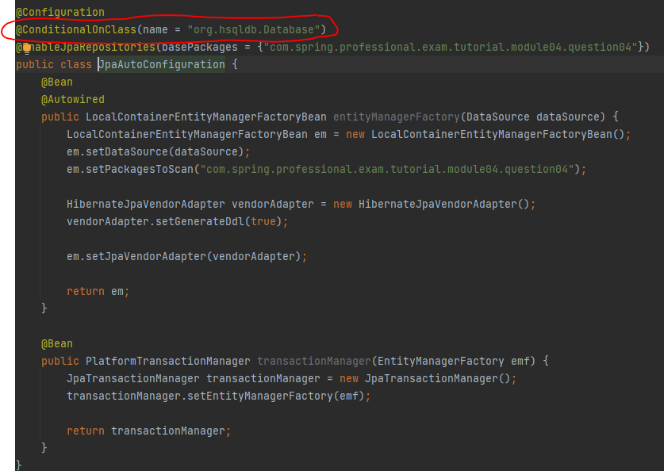

This config will be used whenever we have hsqldb in dependencies .

1. Inside DatasourceAutoConfiguration:

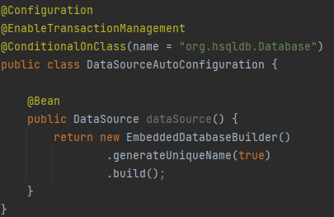

This will be loaded whenever we have hsqldb in dependencies .

1. **What is a Spring Boot starter POM? Why is it useful?**

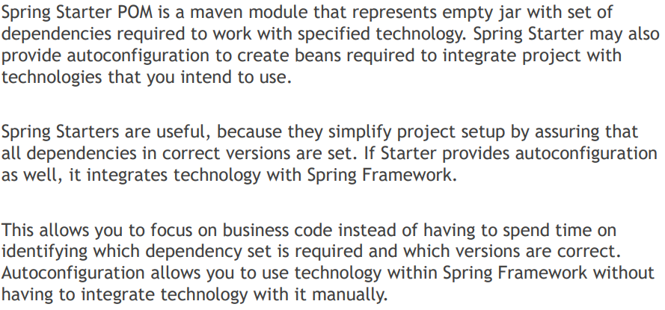

1. **Spring Boot supports both properties and YML files. Would you recognize and understand them if you saw them?**

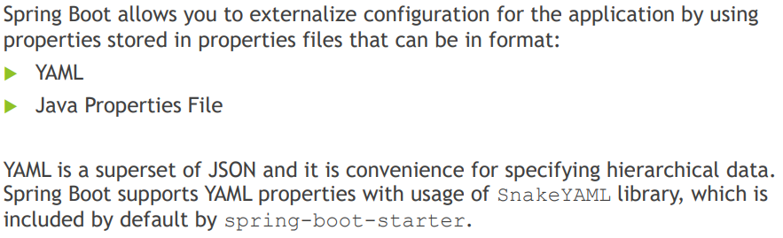

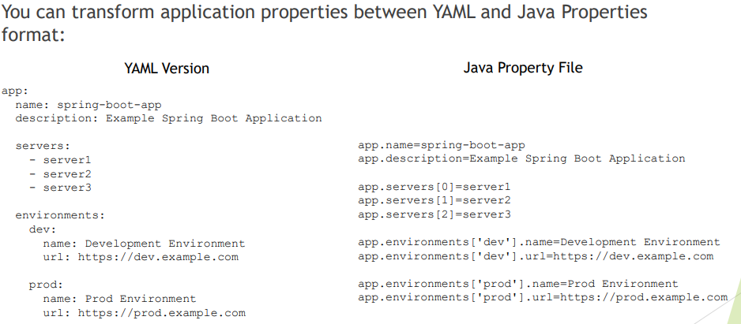

There is an automated way to map the config from .yml or .properties to class by:

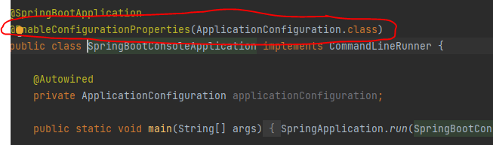

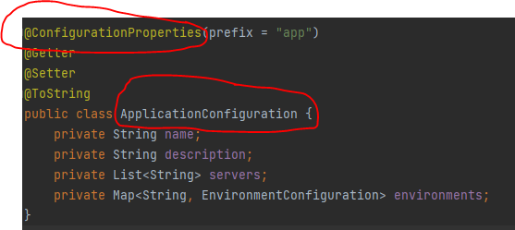

1. **How to control and define logs in spring?**

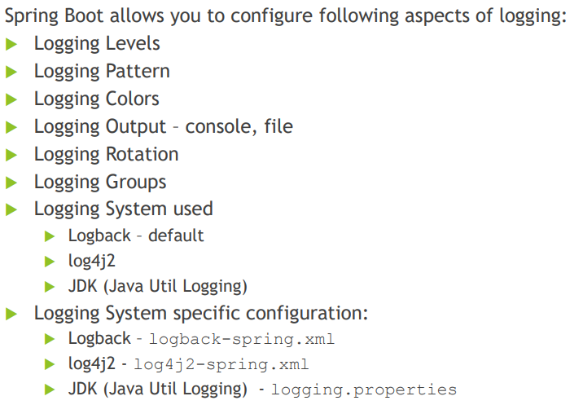

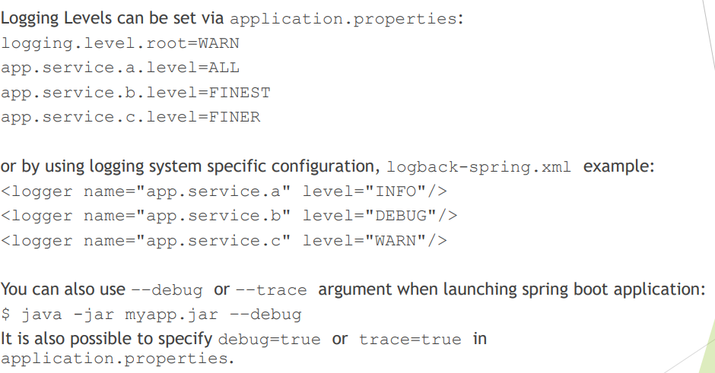

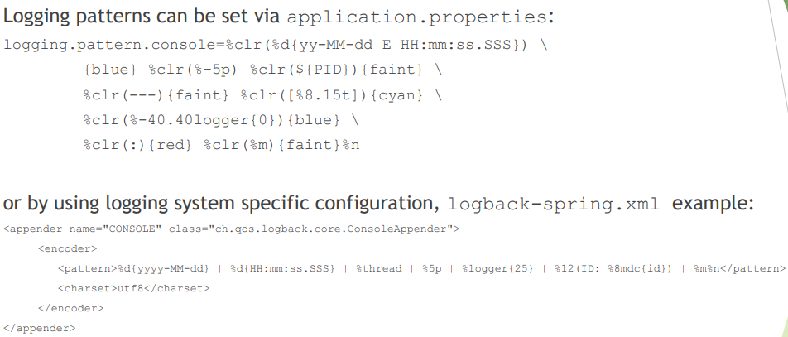

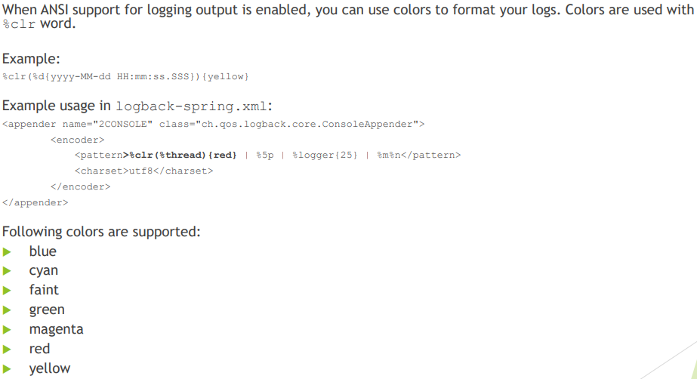

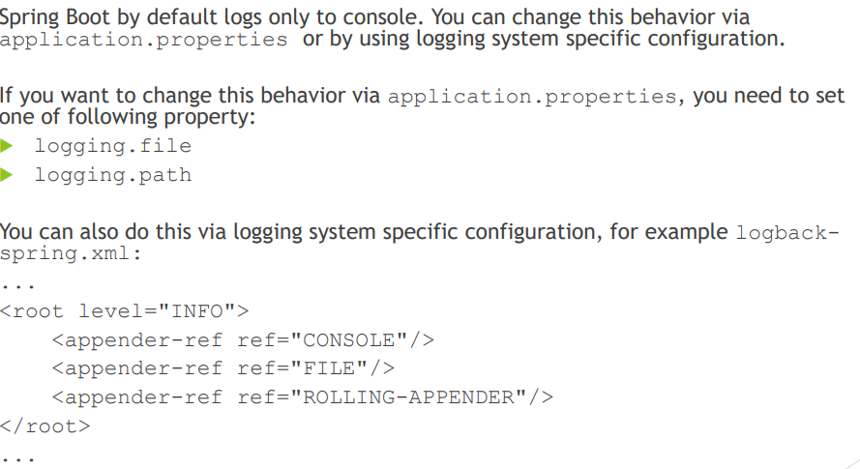

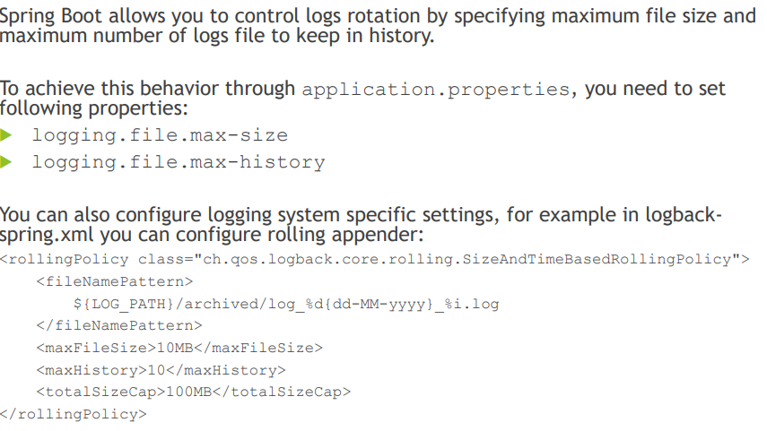

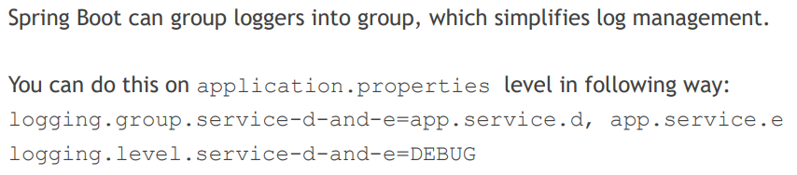

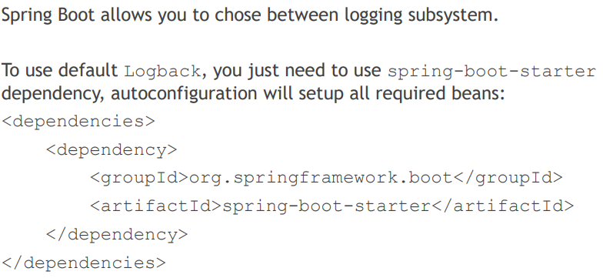

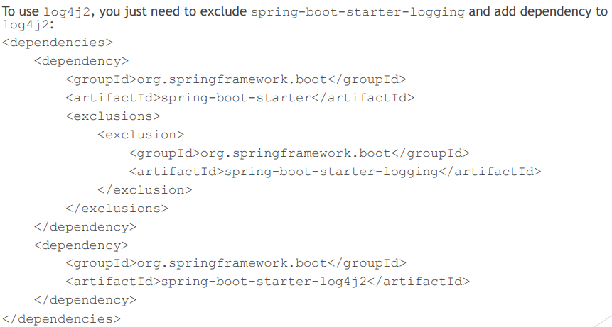

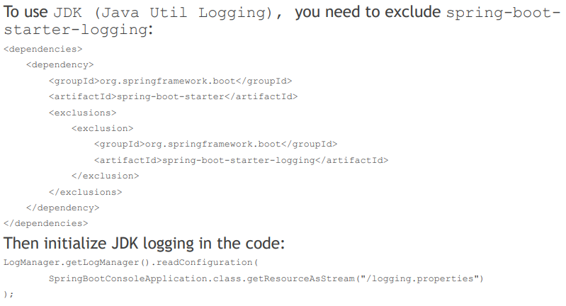

Please read module07-q07

1. **Where does Spring Boot look for property file by default?**

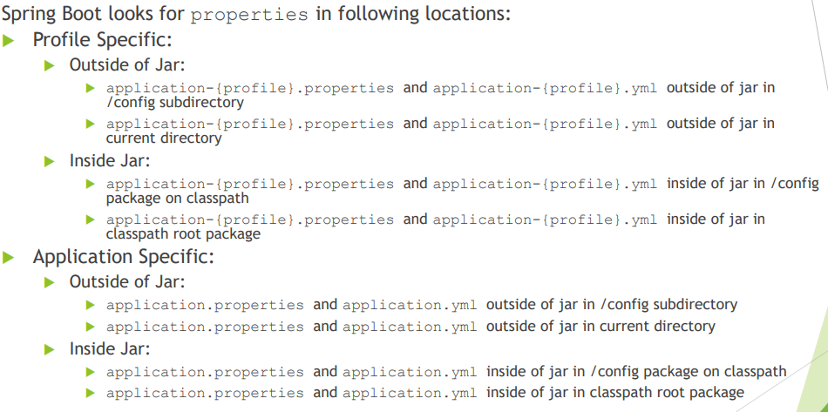

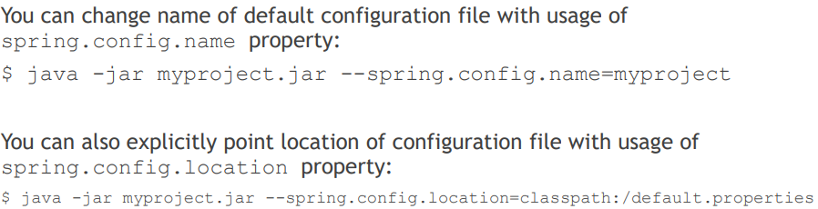

1. **How do you define profile specific property files?**

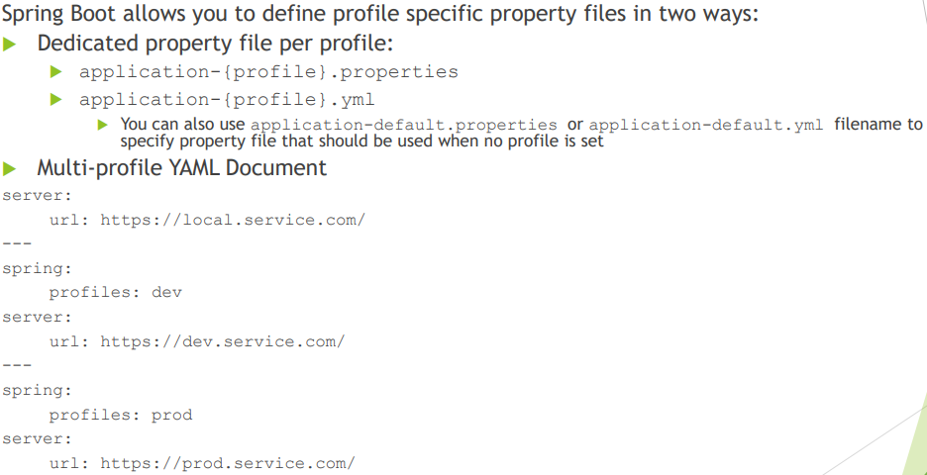

1. **How do you access the properties defined in the property files?**

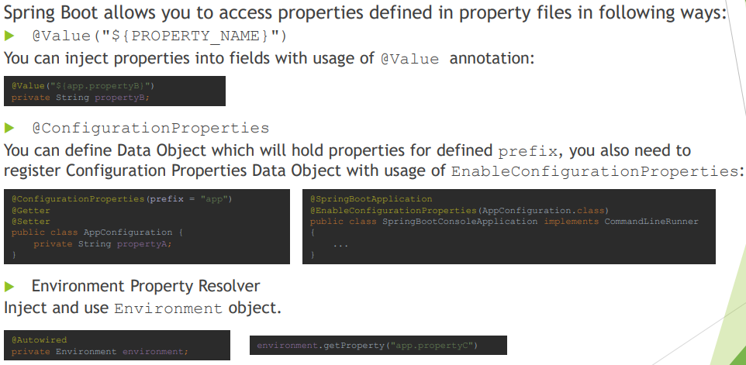

1. **What properties do you have to define in order to configure external MySQL?**

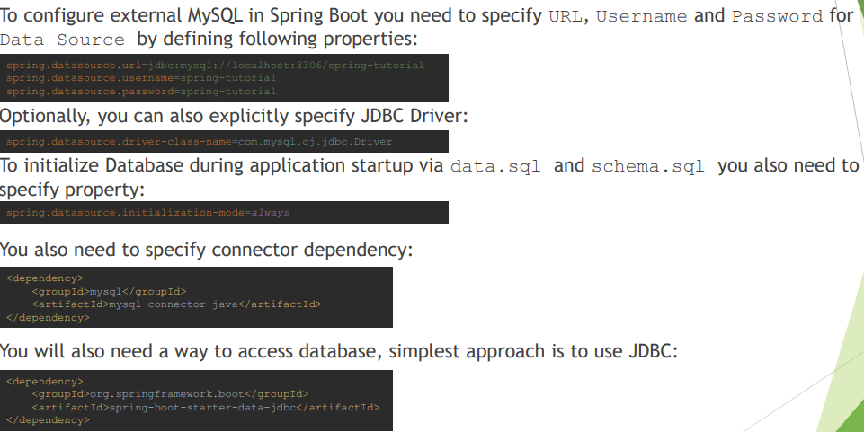

1. **How do you configure default schema and initial data?**

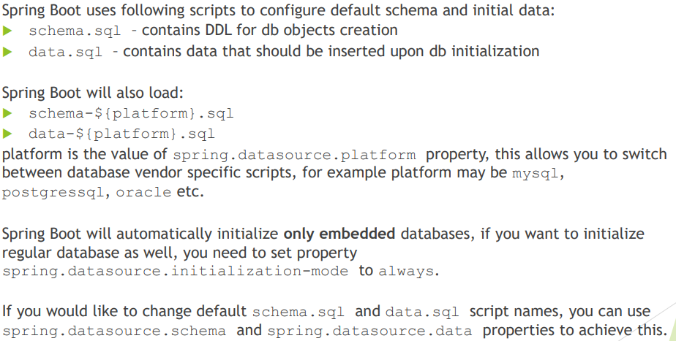

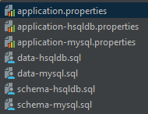

And in application.proprties we specify active profile:

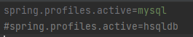

1. **What is a fat jar? How is it different from the original jar?**

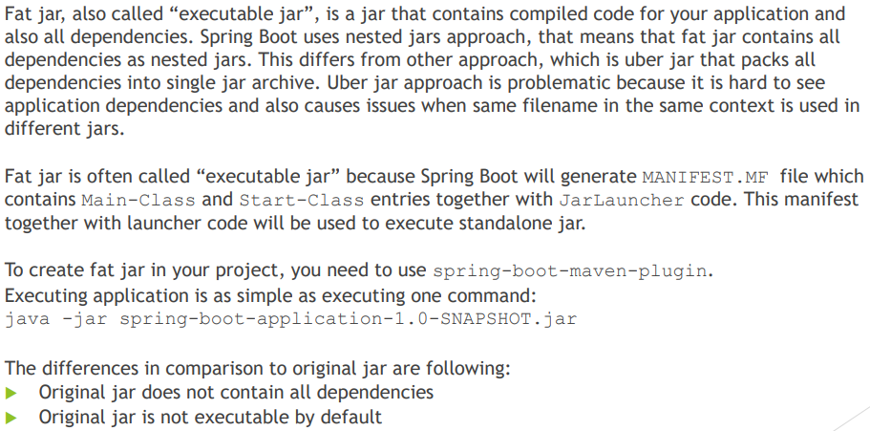

In pom.xml we need to add the following code to build fat jar.

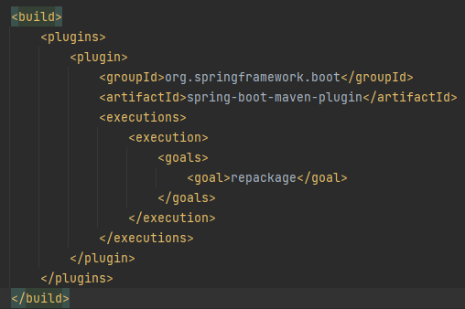

1. **What is the difference between an embedded container and a WAR?**

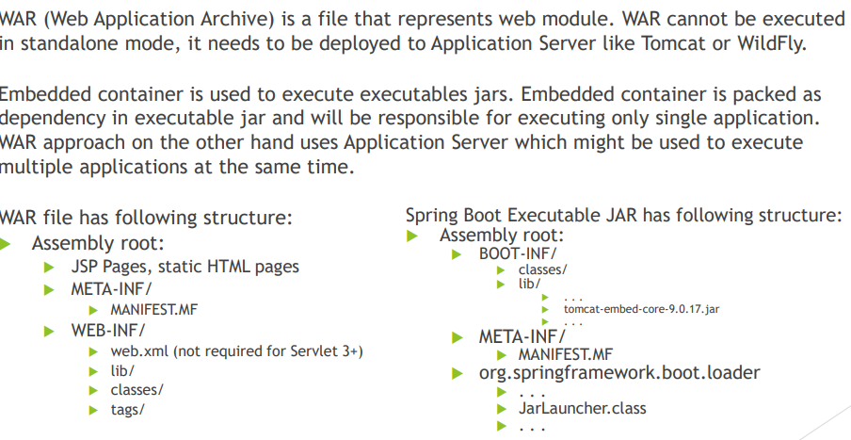

To create a “war” file then need to do the following

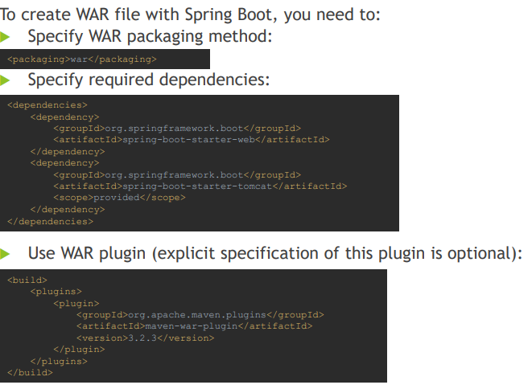

As we can see we marked tomcat as provided coz this war will be deployed in application server and no need embedded tomcat inside.

To create jar file:

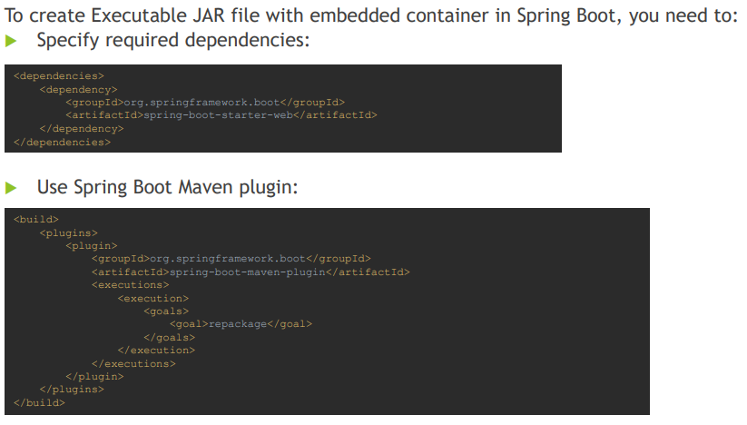

You can refer to module04-q014

1. **What embedded containers does Spring Boot support?**

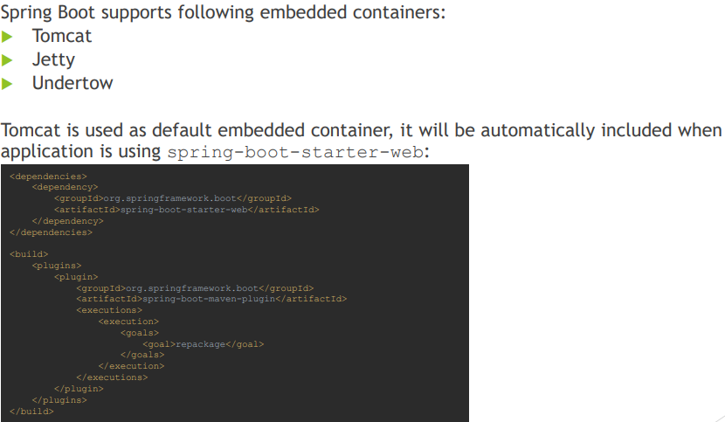

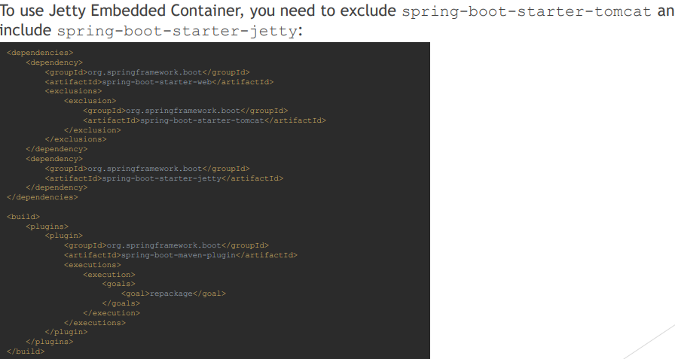

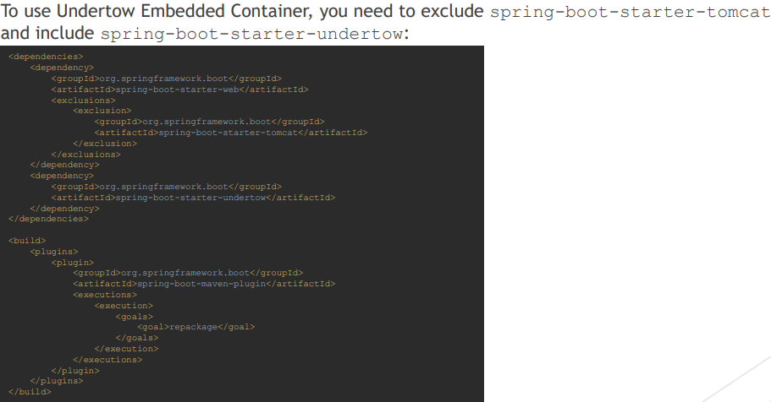

1. **How does Spring Boot know what to configure?**

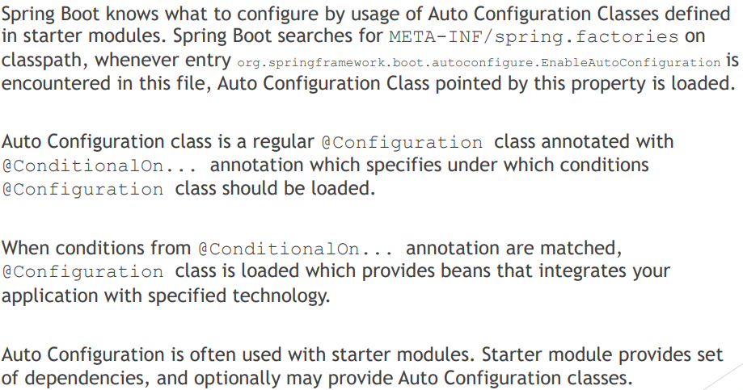

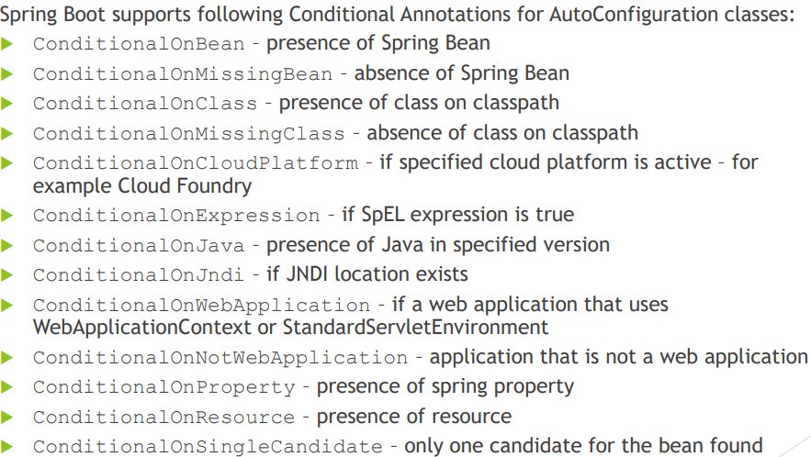

In the following example we have application and dependencies:

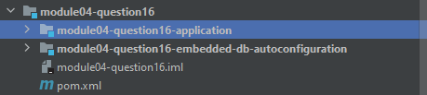

In application level we have added db-autoconfiguration module as dependency:

And then in db-autoconfiguration module we have spring.factories that will load the autoconfig:



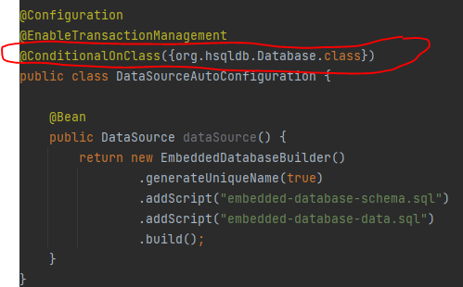

In the dependency module we have at pom.xml:

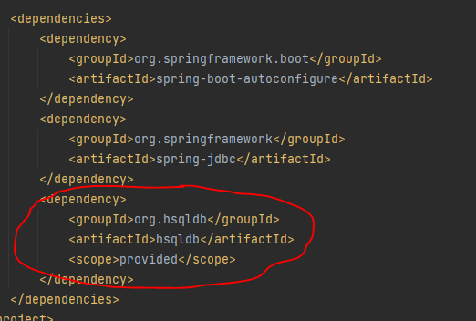

So whenever hsqldb used in the dependency it will load this autoconfig.

1. **What does @EnableAutoConfiguration do?**

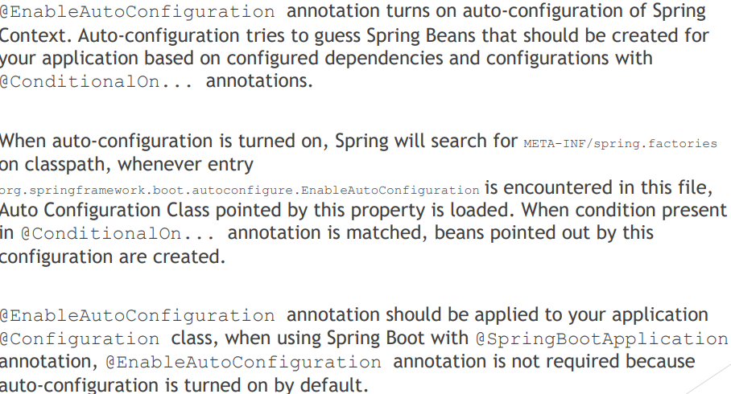

For reference: Module04-q17

1. **What does @SpringBootApplication do?**

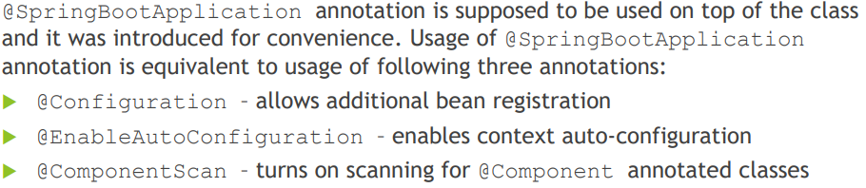

1. **Does Spring Boot do component scanning? Where does it look by default?**

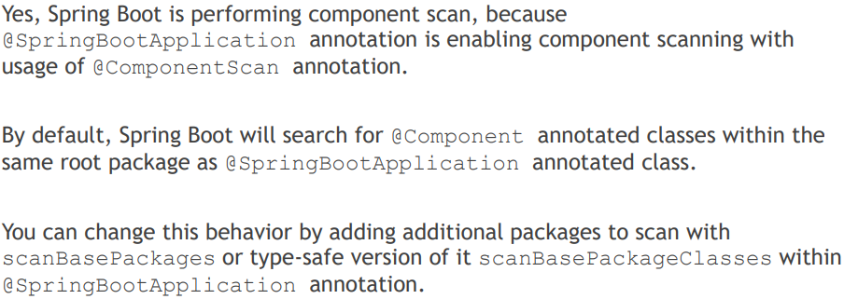

@SpringBootApplication will search for all stereotypes within the same package:

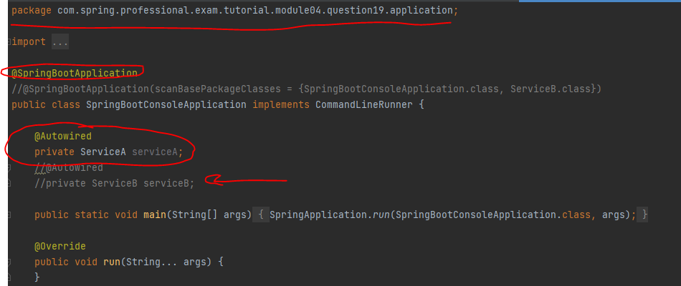

ServiceA exists within the same package that’s why it autowired correctly ,

But for ServiceB it exists in different package

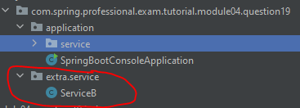

To solve this we will use scaeBasePackages:



This will read the packages for SpringBootApplication.class and ServiceB.class and read all the stereotypes and load them.

1. **How are DataSource and JdbcTemplate autoconfigured?**

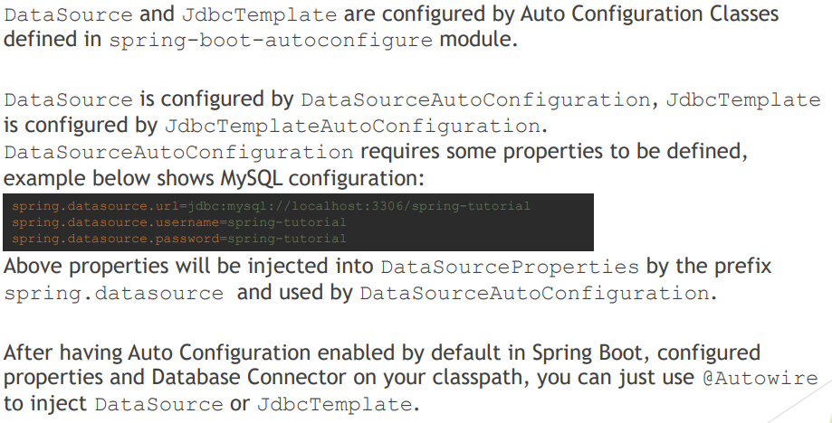

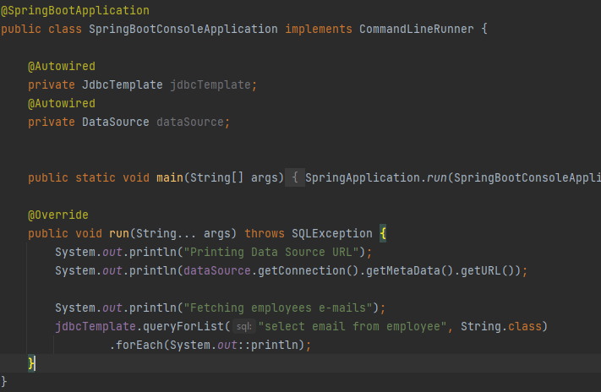

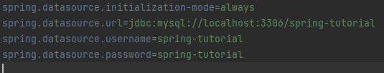

And in pom.xml

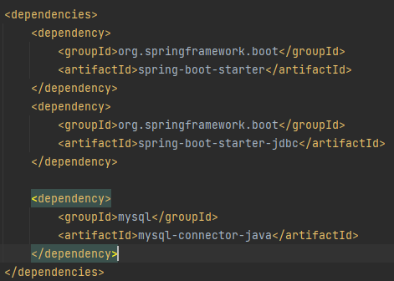

1. **What is spring.factories file for?**

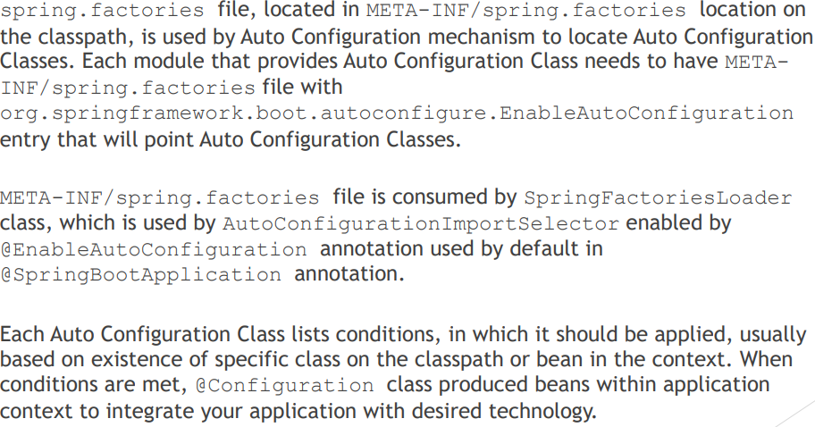

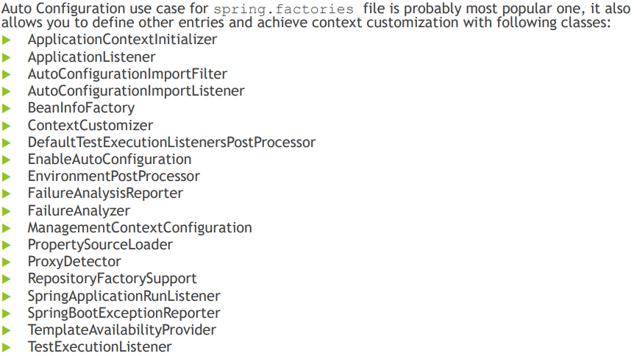

Example for eventListener:



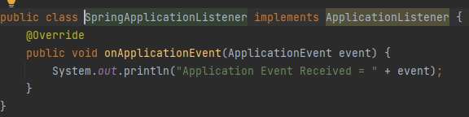

For EnableAutoConfig:



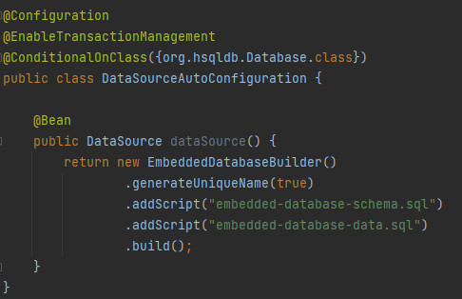

1. **How to customize spring auto-config?**

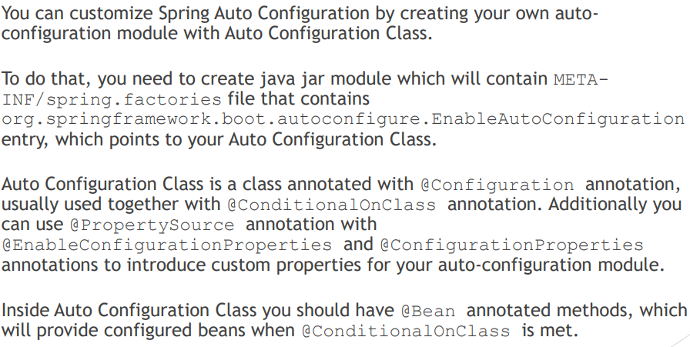

Take a look at module04-q22

U will see that configuration file is named as mysql.properties not application.proprties bcoz we customized .

1. **What value does Spring Boot Actuator provide?**

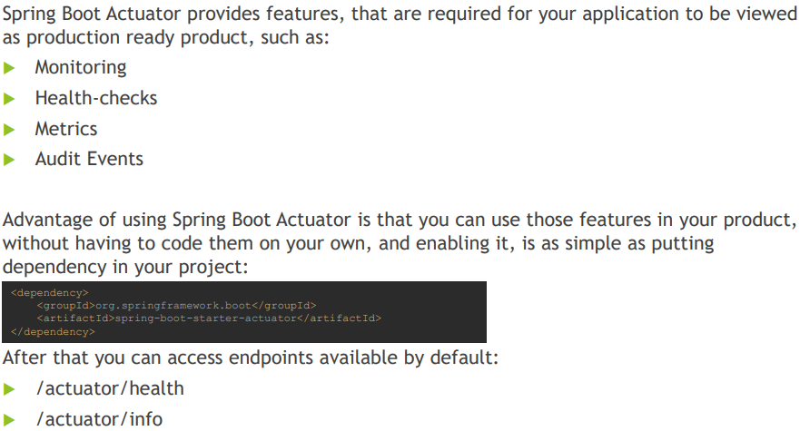

1. **What are the two protocols you can use to access actuator endpoints?**

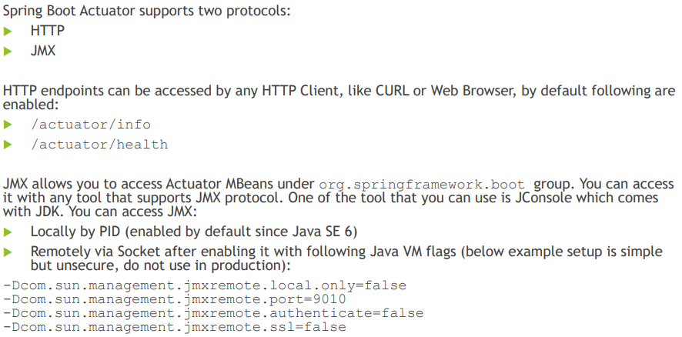

1. **What are the actuator endpoints that are provided out of the box?**

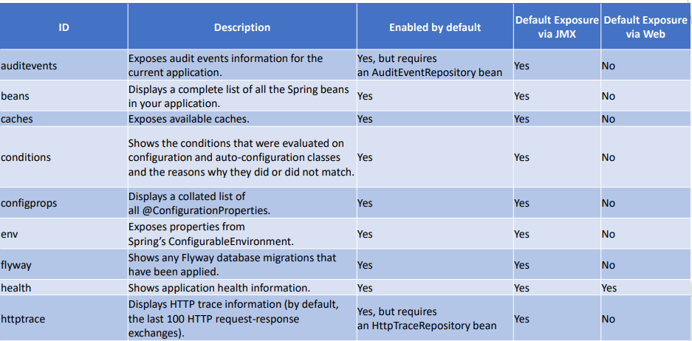

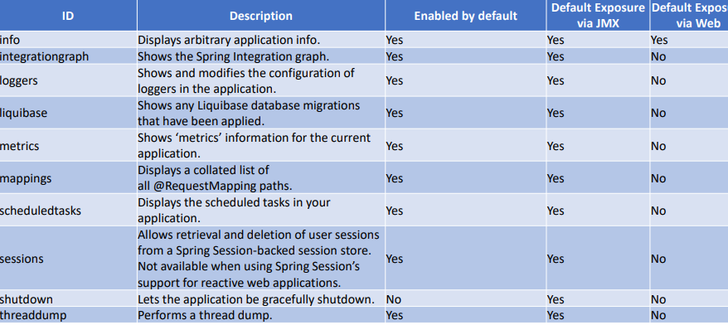

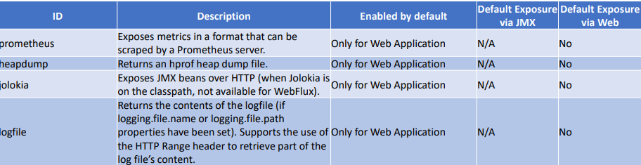

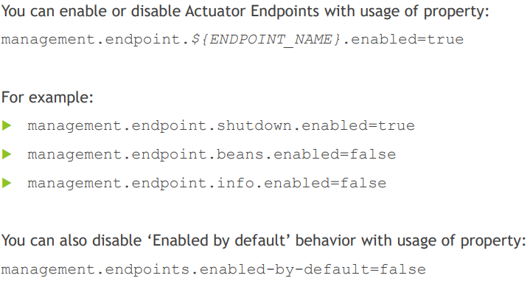

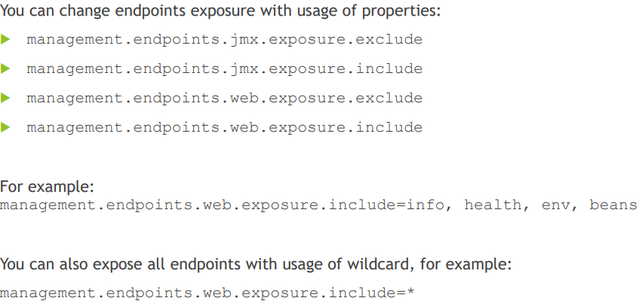

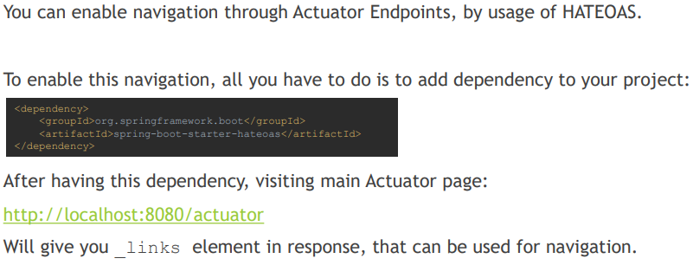

1. **What is info endpoint for? How do you supply data?**

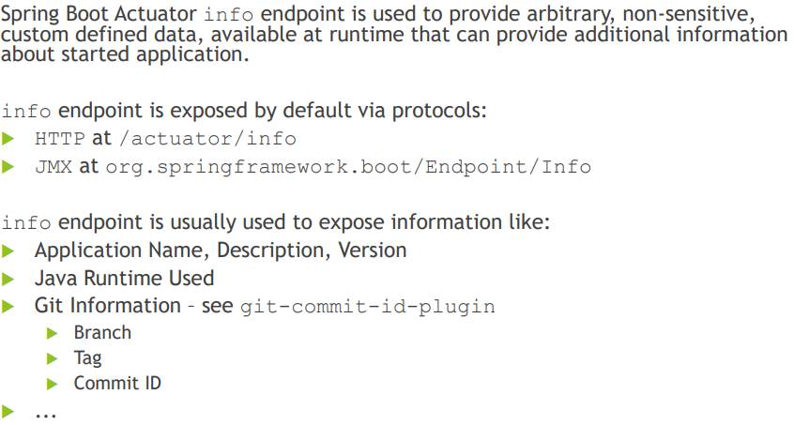

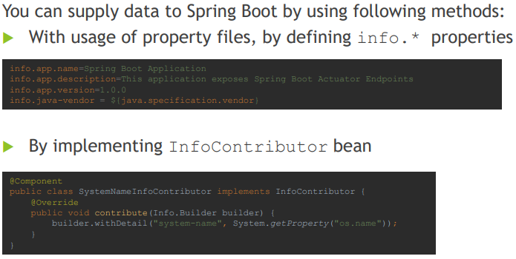

1. **How do you change logging level of a package using loggers endpoint?**

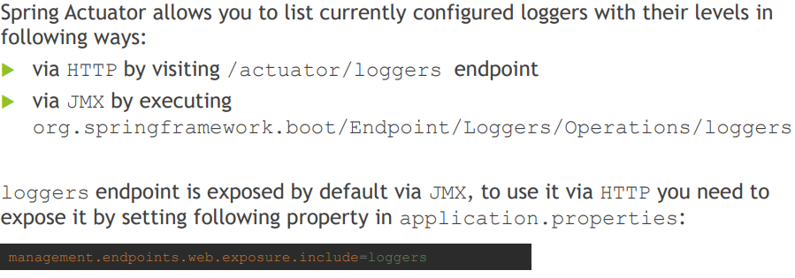

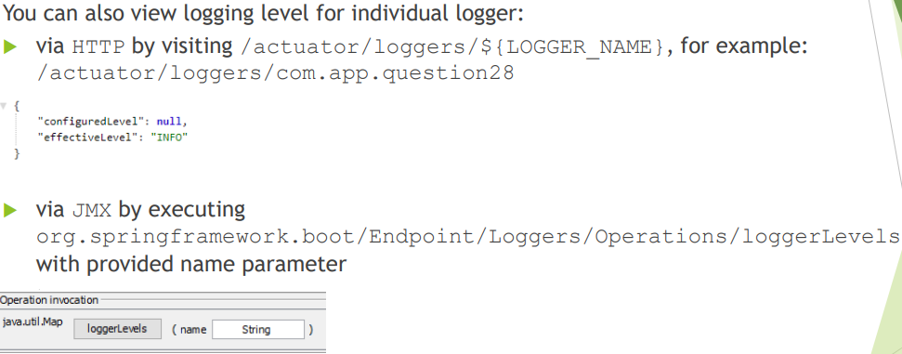

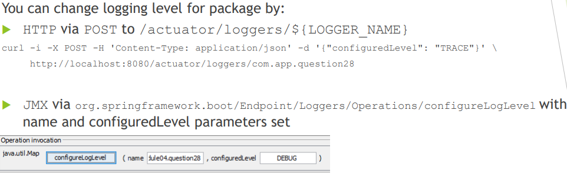

1. **How do you access an endpoint using a tag?**

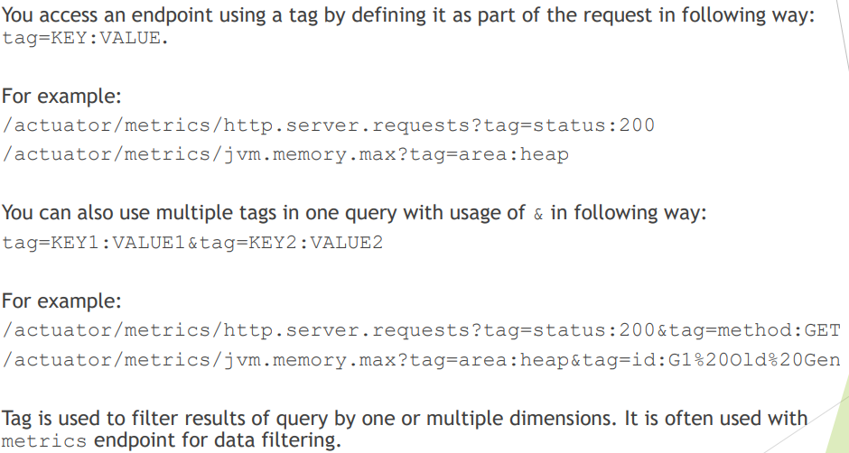

1. **What is metrics for?**

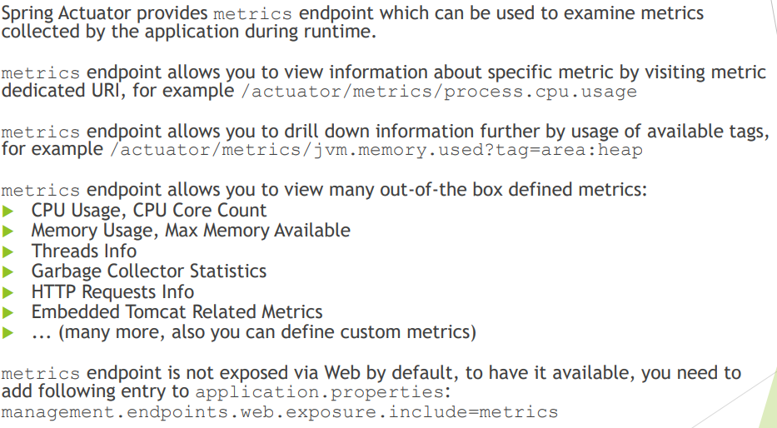

1. **How do you create a custom metric with or without tags?**

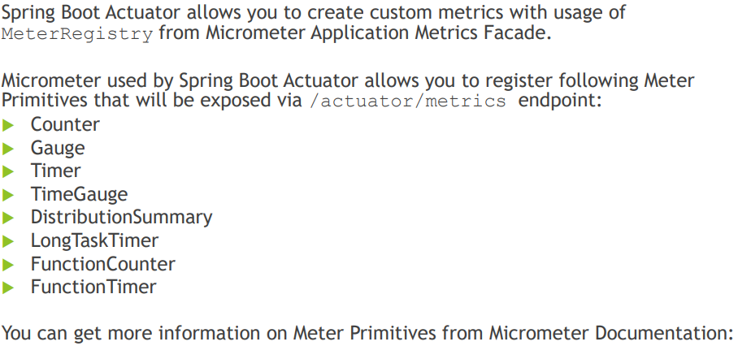

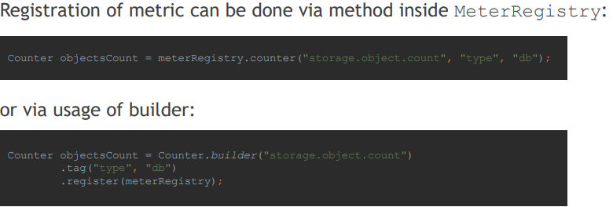

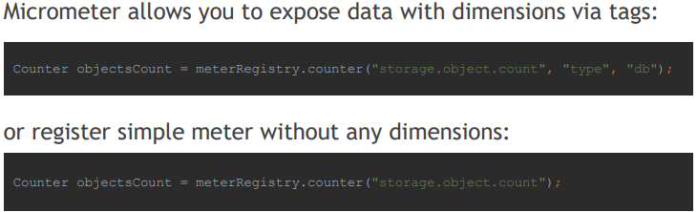

1. **What is Health Indicator?**

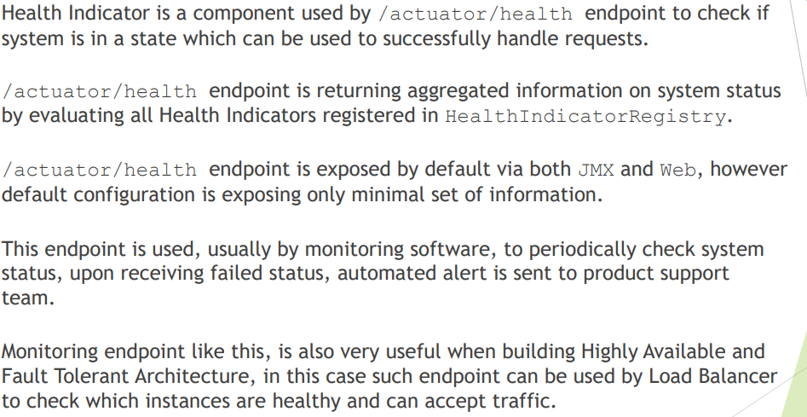

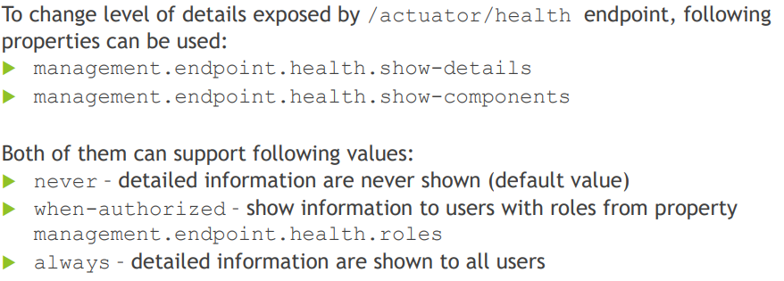

The above configs will show more details on how spring will decide if system up or down.

We can also register a custom component to show in health indicator:

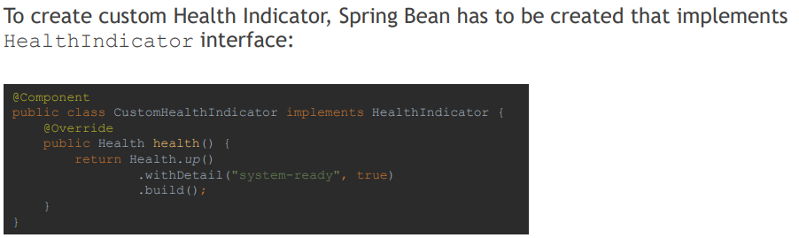

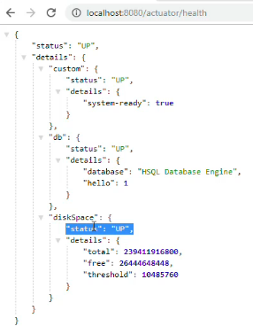

1. **What are the Health Indicators that are provided out of the box?**

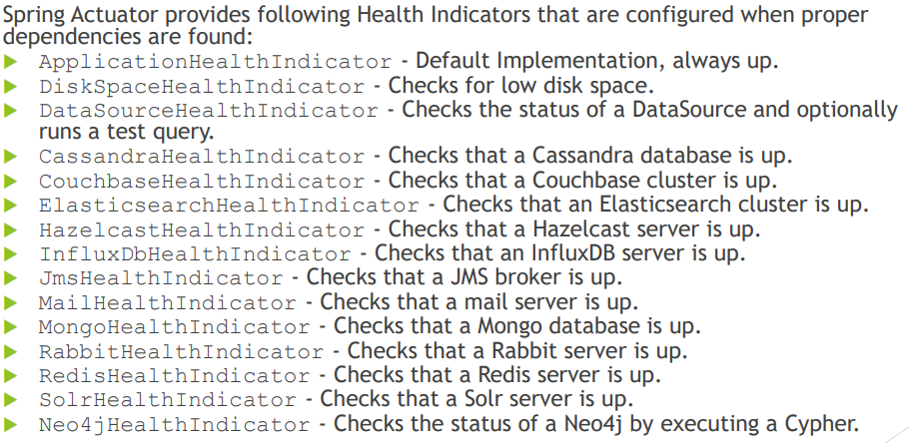

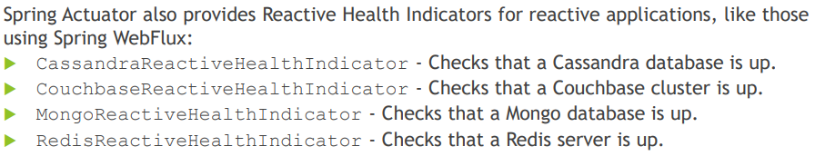

1. **What is the Health Indicator status?**

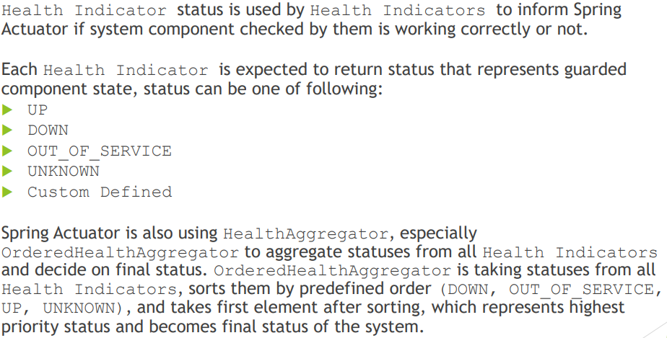

1. **What are the Health Indicator statuses that are provided out of the box?**

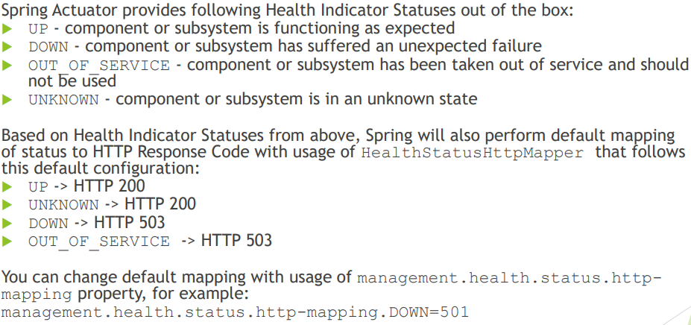

1. **How do you change the Health Indicator status severity order?**

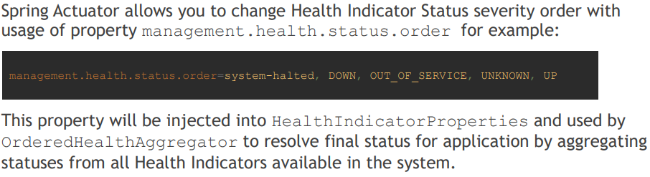

1. **Why do you want to leverage 3rd-party external monitoring system?**

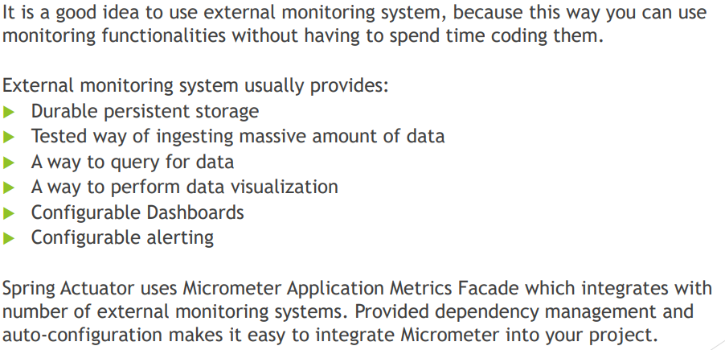

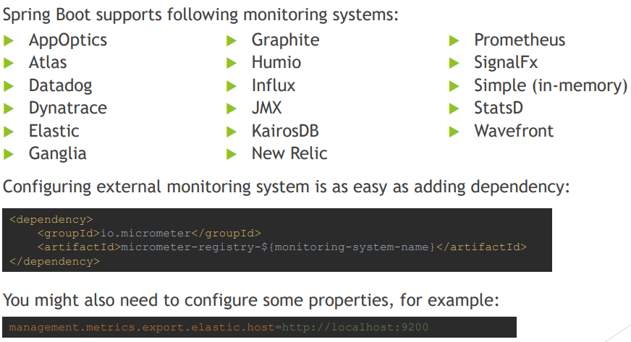

1. **When do you want to use @SpringBootTest annotation?**

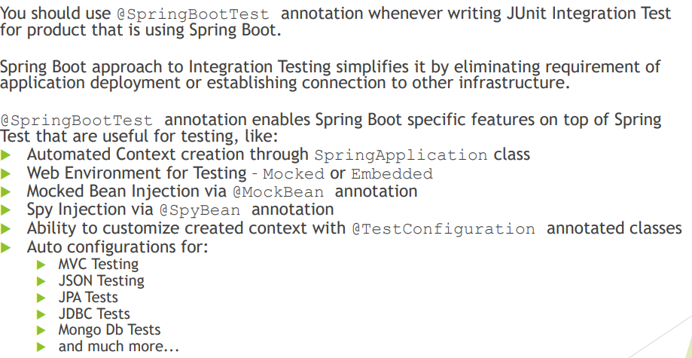

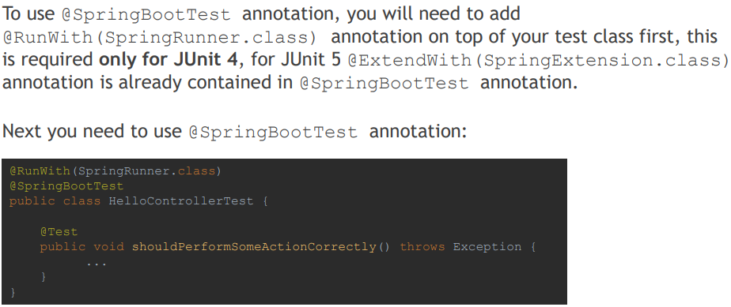

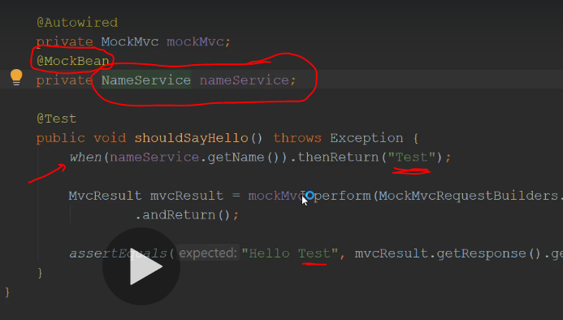

We mocked nameService bcoz it return random values , that’s why we need to mock it for this integration test and see if returning Hello Test .

1. **What does @SpringBootTest auto-configure?**

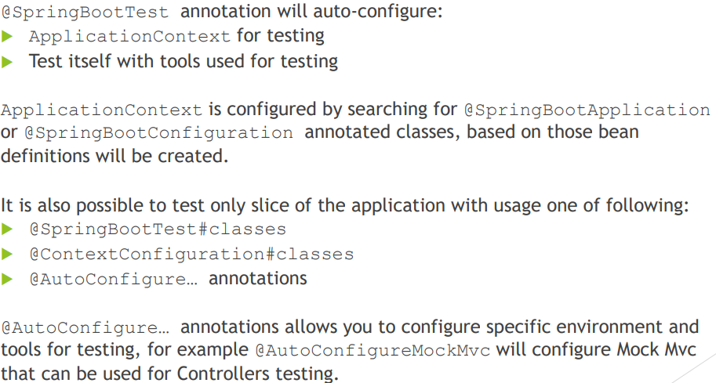

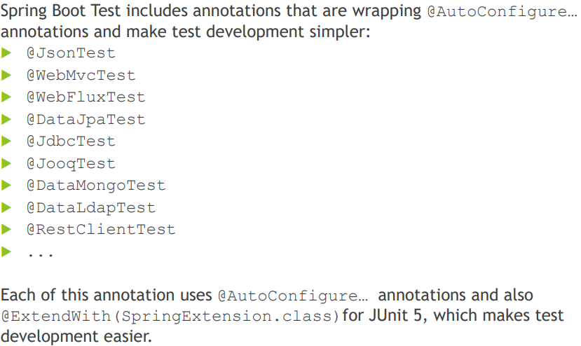

Here we have list of tests:

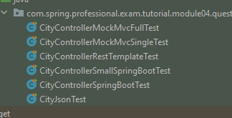

* CityControllerMvcFullTest:

Here we perform full test of our application (integration test), so we have MockMVC that will send requests to our app:

Look at module04-q39.

* CityControllerMockMvcSingleTest:

Here we want to test only one single controller which is CityController.class that’s why we need to mock CityDao

Look at module04-q39 , if we didn’t mock cityDao then compilation will fail bcoz CityDao is missing.

There is no real datasource here in this test bcoz we are mocking it using cityDao mockbean

* CityContollerRestTemplateTest:

This will use restTemplate to test API endpoints.

Refer to module-04-q39.

* CityControllerSmallSpringTest:

This will not use MvcTest , it will just mock CityController and CityDao and perform the test

Refer to module-04-q39.

* CityJsonTest:

Will check json if serialized correctly.

Refer to module-04-q39.

1. **What dependencies does spring-boot-startertest brings to the classpath?**

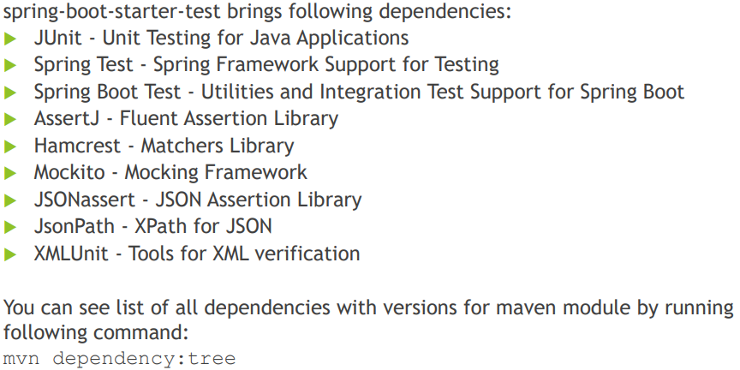

1. **How do you perform integration testing with @SpringBootTest for a web application?**

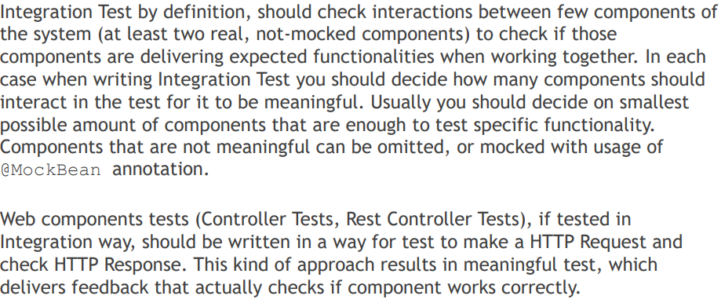

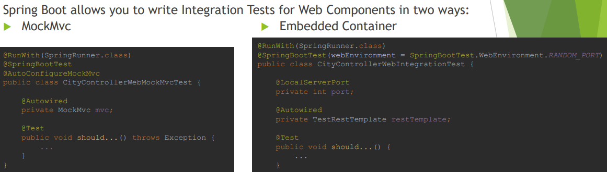

1. **When do you want to use @WebMvcTest? What does it auto-configure?**

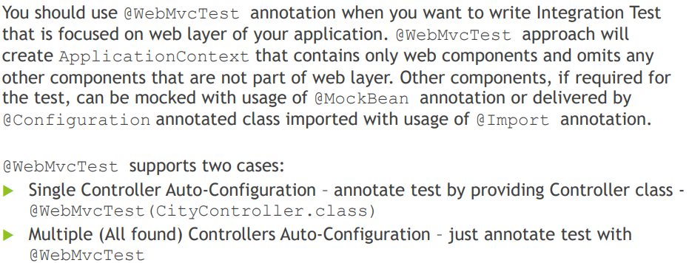

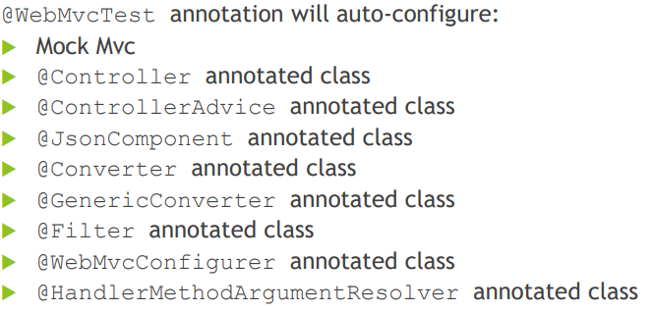

Refer to module04-q42

1. **What are the differences between @MockBean and @Mock?**

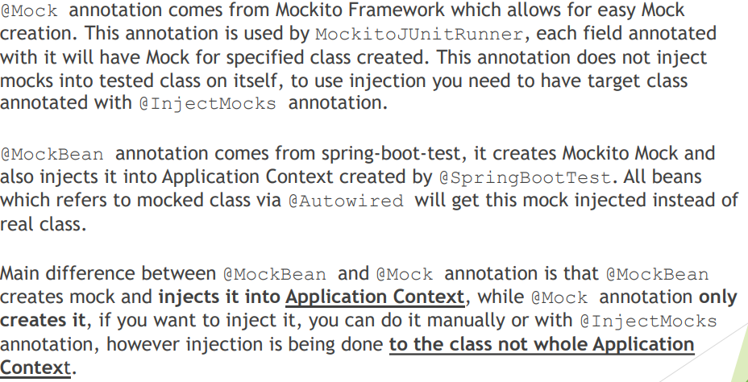

@InjectMocks will not require ApplicationContext to be launched.

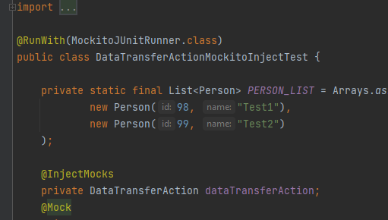

In @Mock we need to inject the bean manually to class:

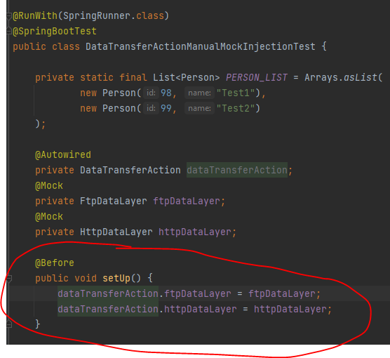

Refer to module04-q43

1. **When do you want use @DataJpaTest for? What does it auto-configure?**

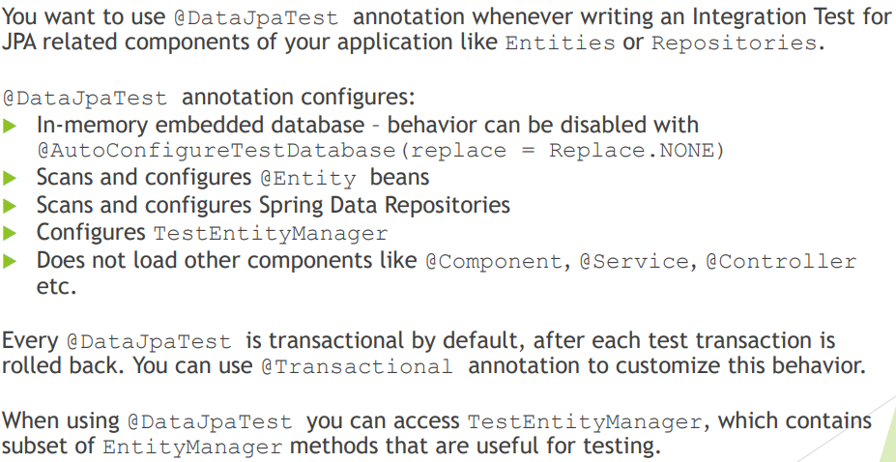

Refer to module04-q43